LOM® Solution Centred Art Therapy

Changing images changes emotions
Our everyday language knows the connection between emotions and images. This is evident when we say: “This is a disturbing image, that one is soothing”. Artists evoke emotions through painting.

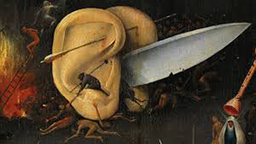
Hieronimus Bosch Gottfried Honegger2

When clients come to art therapy they suffer from disturbing images and emotions. LOM® is a method based on changing images and thus changing emotions. The brain will react to this changed image, whereby the trauma will end, and the pain will stop.

In 1989 Jörg Merz, a Psychotherapist and Bettina Egger an Art Therapist, found common grounds of interest while seeking to improve therapy by combining psychotherapy with art therapy. We began to observe closely which paintings had a positive impact on the patient. For example, we discovered that a simple portrait can resolve a conflict with the person on the portrait, without having to talk about it.
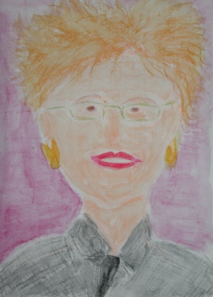
Another interesting observation was that painting a simple image, like an apple, a fruit, a balloon, changed upsetting feelings like fear and anxiety, sadness, anger, into calm feelings. (see case 4). The third observation, in trauma cases, was that great relief could be brought on, when we encouraged the patient to paint the worst of what was seen during the traumatic event, through a step-by-step process (see cases 3 and 5). The development of these findings into a method took many more years of meticulous documentation.

In the meantime LOM® is a well-researched method of Art Therapy. In Switzerland Art Therapy is acknowledged as a profession by the nation and used widely in psychiatric clinics, therapeutic pedagogy, and institutions for the disabled and the elderly. The method is now also being applied all over Europe. The main concerns in LOM® are traumata, posttraumatic stress disorder, relationships, unsatisfactory behavior, cognitions, dreams, decision making, endings and beginnings, body pain and any other issue someone wants to work on.

The basic LOM® intervention is based on the following steps:
- Paint what was seen
- Use metaphors for experiences that have no image
- Put unsettling images into order

Example case 1 : The dying mother3
Elisabeth came to LOM® Therapy because she woke up every night to the image of her mother in a state of terror. Her mother was old and in the hospital. Elisabeth frequently visited her. One day, while visiting, the doctor was there telling her mother that she didn’t have much more time to live. The mother was shaken up and shocked and Elisabeth saw the horror in her face.

In LOM® therapy, we asked her: “Paint the face of your mother as she looked at you in terror”.

Painting 1:
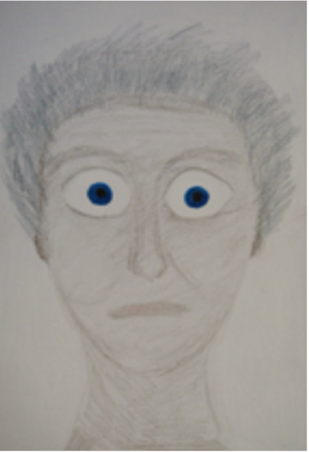
After completing the painting of her mother with a shocked face, we asked her to paint the face of her mother as it normally was. This was done by painting over the first portrait and bringing her mother’s normal expression back to the eyes and mouth.

Painting 2:
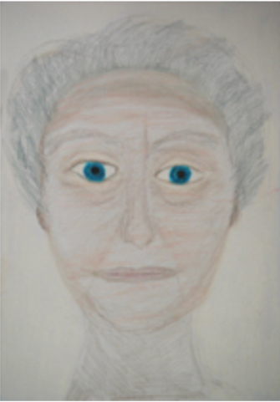

Elisabeth’s flashbacks, the terrible feelings and the persistent crying stopped after that.

This procedure of LOM® Therapy is called “to put it in order”. A shock always impresses long-lasting images in the brain. These images then produce difficult emotions. To change the emotions the image is first painted the way the traumatized person sees it (Painting 1) and then is overpainted into a non-threatening version (Painting 2). The last version will be remembered. In an interview the neuroscientist Prof. Dr. Joseph LeDoux from NYU explained: “When you want to change something in the brain, it has to be destabilized. Only in an insecure situation change can happen. At that point a new image will be able to cover the old one and the brain will remember the new image.” In LOM® Therapy this destabilization is exposed by the painting and thereby can be changed by painting over and creating a new, stabile image.

Example case 2 : Car accident
Eva, a kindergarten teacher, suffered a severe whiplash in a car accident. She was bedridden half the day and could scarcely work 50%. She came to LOM® Art Therapy because the medical care did not help her with her neck pain nor with the continuing terrible emotions.
When we asked her, what she had seen right before the crash, she couldn’t remember. Given a bit of time she started remembering that she had seen the dashboard. With that memory, shock, fear and anger reappeared. The fear got worse when she remembered that she had not been able to leave the car on the driver’s side because the door was terribly crushed.

We asked her to “Please paint what you see”

Painting 1/a:
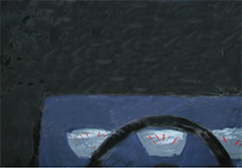
The accident had taken place in an underpass on a rainy night. When asked what she had seen next, it took her a long time to answer. Finally, she said, that there was something like an angle, but she couldn’t say what it was. She was encouraged to paint what she had seen: continuing on the same sheet she first painted the “angle” which turned out to be the windscreen wiper on to the windscreen. When she looked at what she had painted, she suddenly remembered that she had seen the other car coming directly at her.
Painting 1/b:
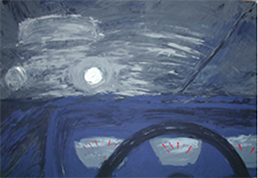

And what was next? She saw the terribly crushed door on the driver’s side. So that was the next image to be painted on a new sheet. As she started to paint it, she just couldn’t paint all the folds and cracks she had in her mind. That is when she realized, that the car-door was only jammed, not crushed. A wave of relief came over her.

Painting 2:
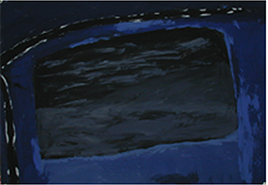

After this work her whiplash started to heal. She not only could work again, she also graduated as an art therapist, got married and had a child. She can only feel the whiplash when she is overworked.

This case shows how memories, especially after traumatic experiences, often are fragmented, inaccurate or distorted. Through painting the brain is updated to reflect reality. Painting allows for a step-by-step process, thereby completing the original memory of the event.

Example case 3 : The broken toy
Cecile came to LOM® Art Therapy because she was deeply troubled with memories of her father. Her father was dead now, but his hot-tempered behavior and violence towards her still stressed her very much and prevented her from living a satisfactory life. When she came to paint, she remembered, that she received a present, a doll’s cradle, which she loved very much. Then one day her father was terribly angry and broke the cradle. The shock and pain of that moment stayed with her. We asked her to “Paint the broken cradle”. Cecile started, but she just couldn’t paint the cradle.

Painting 1:
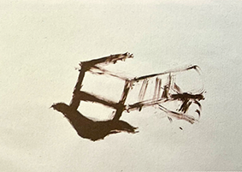

She was desperate, but it just didn’t work. Then suddenly she remembered, that instead of being a cradle it was a little bed that had been broken. This memory allowed her to paint the bed. All the sadness, anger fear of the time came up with this painting.

Painting 2/a:
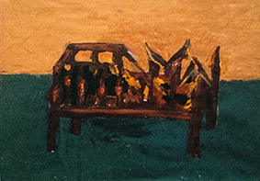

The next painting was of the bed as she had seen it in her childhood when it was new and intact.

Painting 2/b:
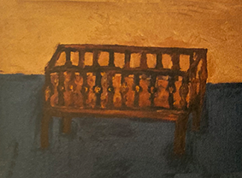

Setting things right, putting them in order is an intervention, which overwrites the old image with the version with which she had had so much pleasure. As in the above example, over-painting the broken bed into the intact version she loved so much allows the brain to remember the new image instead of the old one.

Interestingly in LOM® Therapy when a memory is wrong it cannot be painted. In the process of painting the wrong memory, the right image appears. The recovery of a beloved object, animal or person to an intact condition will always provide good feelings.

Example case 4 : Fear of flying
Hedi came to do LOM® Therapy as she was a frequent flyer, but was very fearful of flying. She could board an airplane only highly drugged and with enough alcohol on top. It was dreadful and an impossible situation.
We asked her, “If your fear of flying were a vessel, which would it be?”
Hedi chose a Spaghetti pan and painted it.

Painting 1:

Soon after Hedi’s LOM® Therapy she had her next flight. She decided to get on the plane and stay sober. She had printed a credit card size image of her spaghetti pan, which she clutched tightly in her hands. Throughout the flight she looked at the image. Flights became easier and easier. She always carried the image with her on every flight, first in her hands, then in her wallet. Today flying is normal to her.

In LOM® Therapy A specific image metaphor is created for incidents that have no image to go with: body sensations, feelings, thoughts, anything that is heard, smelled, or tasted. These image metaphors are simple and well-known items such as geometric forms, fruits, animals, flowers, pastry, vehicles, vessels, and many more. For example, the patient is asked if the incident was a vessel, or a geometric form, or a fruit, etc. what would it be. The patient must let the therapist know the first thing that pops in their mind. This metaphor is then painted. The act of painting itself is important for the outcome . The paint has to be put on the paper by the hand very slowly.. This process convinces the brain that there is no danger and the stress reactions are no longer needed. The metaphor is something simple and nonthreatening. The new image and the new emotion enable a long-lasting change.

Example case 4 : Near rape
Ruth is an actress and had not had a role for a long time. She wanted to find a way to get back into her profession. As we talked about this issue, she suddenly remembered a trauma she went through when she was 6 years old. She decided to work on this old trauma. Ruth was a farmer’s child and enjoyed being in the stables with the animals. Her uncle encountered her in the barn and tried to rape her. She crawled underneath the hay. As he wanted her to stay quiet, when she came out from the hay, he offered her a large chocolate bar, a luxury at the time, but she ran away. We asked her, to paint what she had seen: the chocolate bar and the thumb of her uncle.

Painting 1:
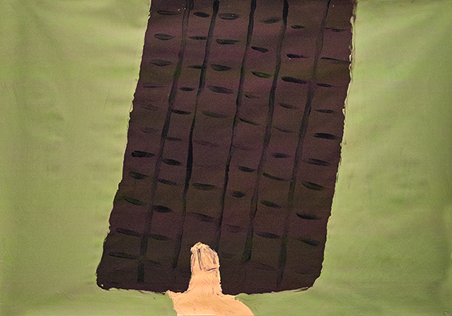

The remembered image was the chocolate bar and his thumb. This had to be painted.

While offering her the chocolate bar the uncle had said: “take this and don’t say anything to anyone.” We asked her, “if this disturbing sentence were a geometric form, which would it be?”

Painting 2:
This disturbing sentence was put into a metaphor.

She could also still smell him and had a terrible taste in her mouth: We asked, “If the bad smell and the bad taste were a geometric form, which would it be?”

Painting 3:
This disturbing smell and taste were put into a metaphor.

She still remembered the image of the naked legs and the crumpled pants. It was very difficult and disturbing to paint this image.

Painting 4/a:
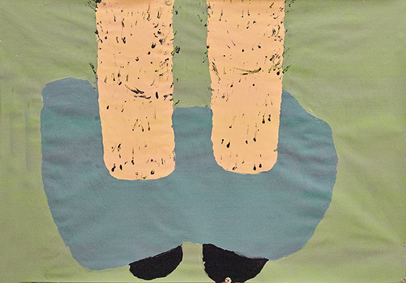
The disturbing image had to be painted. Then it was time to eliminate this memory. We asked her to “Pull the pants up and get the shoes clean.” The painting has to be put in order.

Painting 4/b:
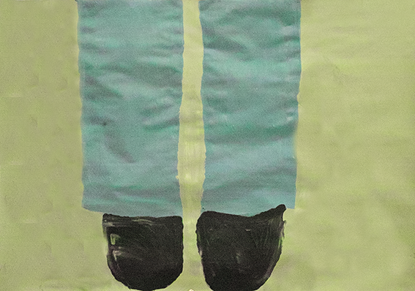

The relief was big, when this painting was finished.

We told her that, “What you went through was terrible and you still accomplished a courageous life. This needs to be appreciated,” and we asked her: “If the appreciation of how well you went on in life were a fruit, which would it be?” She painted a mango.

Painting 5:
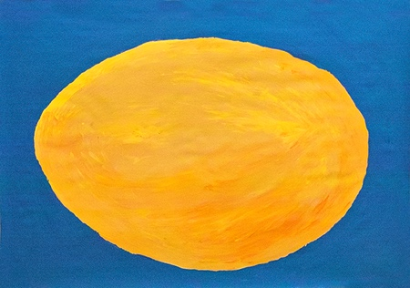

With new verve she started to look for a job as an actress. 4 weeks later she worked on stage.

In LOM® Therapy it is important to work through a traumatic experience step by step, remembering all aspects of the experience, in this way each sensory aspect can be resolved in the brain. The final step is to acknowledge the survival of the trauma and a self-appreciation for one’s strength in dealing with it. To understand a difficult time is important for the future process.

All the cases presented above are from adults, however LOM® Therapy is also very effective with children and adolescents. The selection of cases are examples of the variety of uses for LOM® Therapy and the application of the basic steps :

- Only paint what was seen
- Use metaphors for experiences that have no image
- Put unsettling images into order

Research
The authors developed the LOM® Method in 1990 and since then have been teaching the basics of LOM® and continuing education workshops. From the beginning all processes were recorded as well as the state of the condition of the painters. Special emphasis was laid on the topic of the extent of distress. The extent of distress was estimated before starting the therapy, at the end and a few months later as a follow-up. We named the variable: extent of distress SUD (Subjective Units of Distress4). Our question was: “From 0 to 10, how much are you distressed by your ‘problem’5? 0 means you are not at all distressed, 10 means the highest possible distress”.
In the study were totally 848 persons involved. The Problems were divided in the subsequent
categories: Depression: 163; Fear and anxiety: 173; Conflicts in Relationships: 179; Traumatic experiences: 226 (Posttraumatic Stress Disorder: 193 – see below); Psychosomatic Disorders: 107 and Resource Activation: 95; Total Sample: 848, out of which 633 with follow-up.
Overview: Posttraumatic stress disorders | N
Violence: physical and psychological (by relatives, assault, crime) | 30
Sexual violence | 32
Accident, hospital, operation | 42
Distressing events (Death or separation of family members, heavy body Illness of oneself or relatives | 69
Distressing live events as adult (Death, Separation, severe Illness of relatives, etc.) | 17
Catastrophes, War | 3
TOTAL | 193

In the study involved were a lot of therapists. Beside the authors, experienced LOM® -therapists in clinics and private practices as well as trainees in the LOM® -method participated in the study.
Results:
633 persons were examined at the start, the end and after a period of 421 days to average.
The differences between start and end and between start and follow-up are statistically highly significant (p≤0.001). The differences between end and follow-up are not significant

The treatment of the diverse categories of symptoms showed no statistical significant differences concerning the effectiveness of the LOM® therapy. Also there were no differences found between highly experienced therapists and trainees regarding the efficacy of LOM®.

Follow-up study by Viviane Sterzer:
For her medical dissertation, Viviane Sterzer, chose 60 patients treated by Bettina Egger (Dissertation as PDF for download (in german)). She examined, whether a long-term follow-up (average 34 months (follow-up 2)) would show a further improvement of the symptoms.

The differences between start and end and between start and long-term-follow-up are statistically highly significant (p≤ 0.001). The graph shows impressively how after the end of the treatment there is a continuing improvement of the symptoms.

Prospective Study at the University Hospital Zurich (USZ): Prof. Pierre-Alain Clavien:
At the moment a prospective LOM® study with colon cancer patients will start in the year 2020. Main issues are the course of anxiety and the healing process.

Conclusion
This article gives a glimpse into the possibilities of LOM® therapy. This well-researched method of art therapy can be used in an enormous variety of issues such as traumata, posttraumatic stress disorder, relationships, unsatisfactory behavior, cognitions, dreams, decision making, endings and beginnings, body pain and any other issue someone wants to work on, just by using the basic steps: Only paint what was seen, Use metaphors for experiences that have no image, Put unsettling images into order. The results of LOM® therapy are extraordinary. As displayed in the examples above, the issues that have been problems (in some cases for years) can be resolved within a limited amount of paintings. LOM® therapy is one of the most effective and fastest art therapies to date.

For more information on LOM® in Europe please look at: www.lom-international.org / info@lom-international.org

Hieronymus Bosch: Ausschnitt aus dem Tryptichon "Der Garten der Lüste". https://www.swr.de/swr2/der-maler-hieronymus-bosch-grenzgaenger-zwischen-paradies-und-hoelle/-/id=7576/did=17849354/nid=7576/wo9a0m/index.html
2 Gottfried Honegger: Pro Litteris Schweiz
3 Bettina Egger und Jörg Merz: Lösungsorientierte Maltherapie. Hans Huber, Bern: 2013
4 This variable is used in the EMDR research. See: Shapiro, Francine: Eye Movement Desensitization and Reprocessing; The Guilford Press and Mark Paterson: 1995
5 The ‘problem’ is explicitly be named in full length

